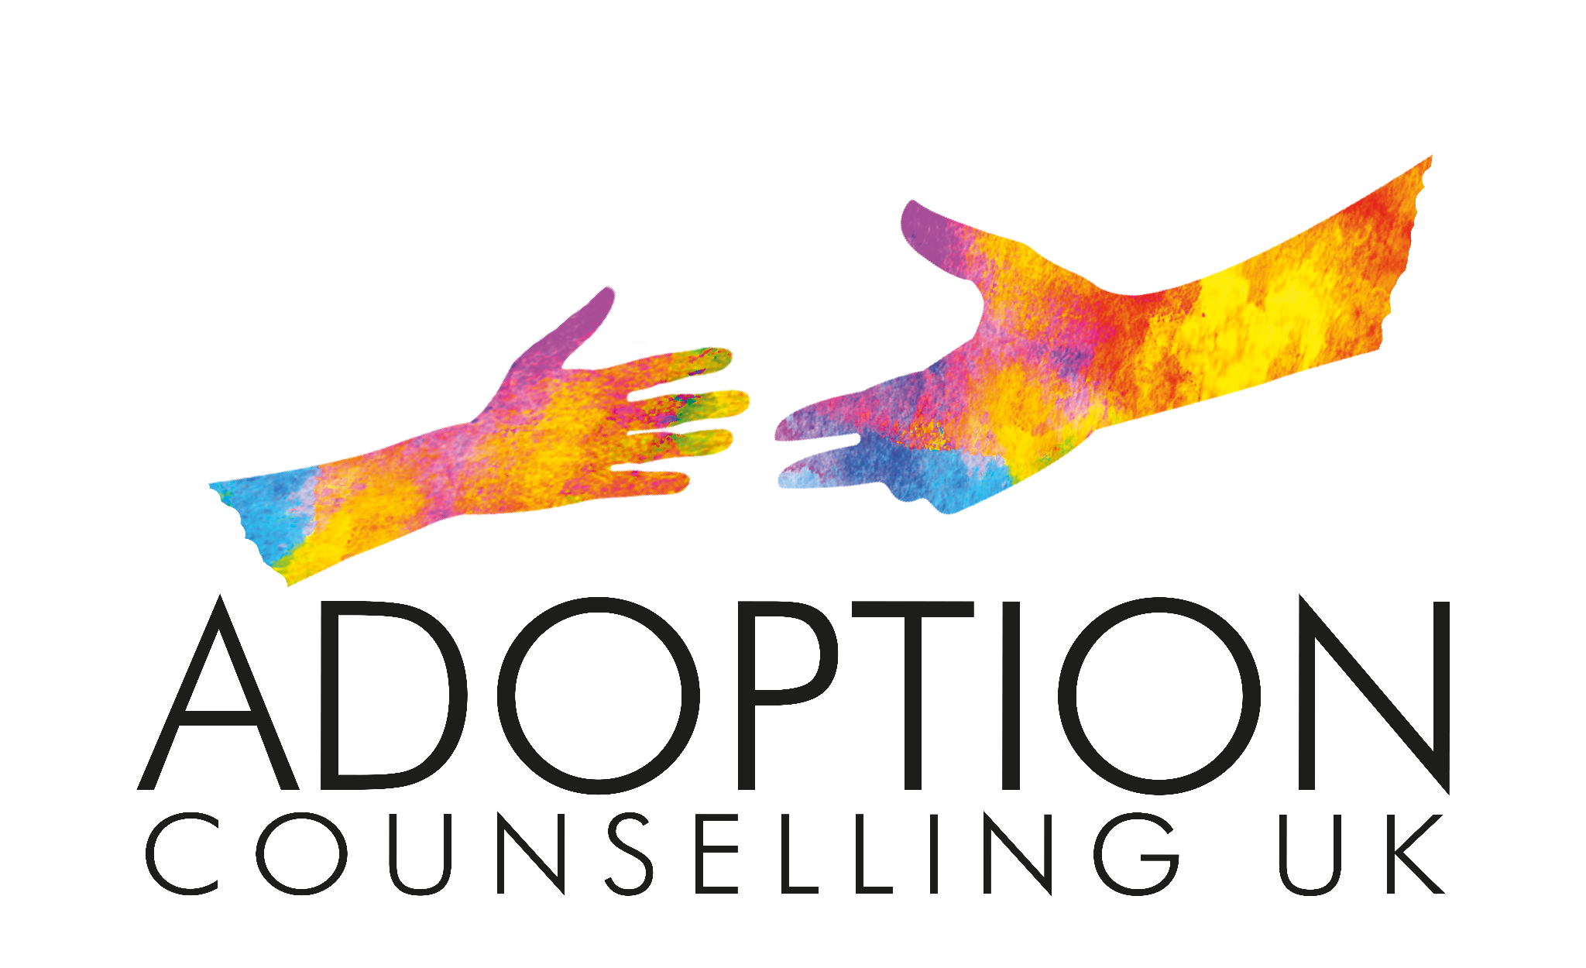

GDPR Data/ Privacy Notice
The following describes what personal data I gather regarding you/ the young person you are supporting, how and why I keep it and what I will do with it.
It also covers your rights around this data. The lawful basis for gathering this is in order to provide psychotherapeutic services to your young person in line with my contractual obligation to you and them.
What information do I gather and why do I keep it?
● Your/ their name and date of birth – these are used as an identifier.
● Address, email and phone number(s) – these are kept so that I can make contact with you.
● Any other information you feel I need to know in order that we can work safely together.
● Session notes that may contain sensitive personal information (e.g. religious beliefs, marital status, financial information) – as a memory aide.
Consent
This policy is discussed at the beginning of our work together, signing this provides consent to use the information. There may be times when I will need to share information externally (see below).
When may your data be shared?
Due to adoption being protected by law, therapists must be registered with Ofsetd, to enable this I work under the umbrella of an adoption support agency (As required by Adoption Agency and Adoption Support Agency Regulations.)
Therefore they will also hold data relating to who I am working with. They are equally bound by the same Data Protection legislation as I am.
There are other occasions when I may share your/ their information with other professionals. These are:
● Your/ their first name may be shared with our clinical supervisor.
● In the event that I receive a court order to provide access to records (I keep very minimal notes as memory aids).
● If you/ they disclose information that raises safeguarding concerns including immediate, serious risk of harm to yourself/ them or others; or abuse or neglect of a child or vulnerable adult. I have a duty of care to disclose that information to the adoption support agency and/or appropriate authorities.
● If you disclose anything relating to terrorism, drug trafficking or money laundering I am legally required to inform the police and it is a criminal offence for us to inform you that Ihave done so.
● In the event of my death or incapacitation your/ their records will be released to a colleague who will then, depending on the stage of the word either: make contact with you and the adoption support agency, continue to store your details or dispose of records in accordance with GDPR regulations.
● If the terms of our working together require it (e.g. to meet an insurer’s or Employee Assistance Programme requirement) – the types of information will be made clear.
How long are these data stored and how is it disposed of?
Contact information will be confidentially destroyed when our work together is complete. Session notes will be kept for 7 years and then confidentially destroyed. Emails, texts and phone records between sessions will be deleted as soon as they are no longer relevant.
Concerns & Corrections
If you would like to have your personal data deleted, please let us know and I will take reasonable steps to delete it (this will be dependent on legal reasons which may require us to maintain certain records). If you have reason to believe that personal data I have gathered is in some way incorrect or now out of date or if you have concerns about how I am handling the data, please contact me and I will work towards resolving those concerns.
Internet Information
Website cookies allow the web provider to count visits and traffic sources so they can measure and improve the performance of the site. They help to clarify which pages are the most and least popular and see how visitors move around the site. Information collected is aggregated and therefore anonymous. You can block these if required. Securing personal data on Emails: you may wish to choose an encrypted email provider.

